Philosophy For Children
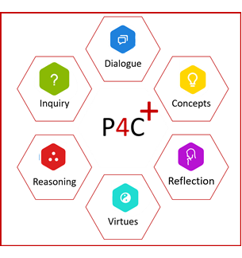
In our school, pupils regularly participate in Philosophy for Children lessons. Philosophy for Children, which is sometimes abbreviated to P4C, aims to encourage pupils and teachers to think critically, caringly, creatively, and collaboratively. It helps teachers to build a “community of enquiry” where pupils create and explore their own questions about important things in life. Research evidence indicates the consistent use of P4C produces significant improvement in IQ scores, raises pupils’ self-esteem and confidence, and makes them more aware of their own and others’ feelings. In addition, P4C develops children’s talking and listening skills and contributes to the delivery of the PDMU (Personal Development and Mutual Understanding) element of the Northern Ireland Curriculum. Together with the other Thinking approaches we use, P4C helps to develop the 5 strands of the Thinking Skills and Personal Capabilities aspect of the curriculum.

