Effective Questioning
“The power to question is the basis of all human progress” (Indira Gandhi – 1975)

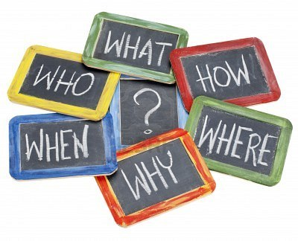
“I had six honest serving men.
They taught me all I knew;
Their names were Where and What and When
And Why and How and Who.”
Rudyard Kipling

We seek to deepen pupils’ thinking skills by empowering them to ask and answer different types of question. These include factual questions, and questions which require interpretation, speculation or imagination. Pupils also learn that some questions may be answered by looking for scientific evidence, while other questions are more philosophical and may have more than one “correct” answer.
To support questioning for enquiry, strategies developed from “Philosophy for Children” (P4C) are used to enable pupils to think critically and collaboratively. Philip Cam’s “Question Quadrant” is also employed to assist pupils in asking Factual, Speculative, Scientific and Philosophical questions in relation to short stories and novels read during literacy lessons.

Textual Questions

Questions we need to discuss
Answers can be found in non-fiction books, websites etc
Intellectual Questions
Use your imagination to answer these questions
Answers can be found in the book
Closed Questions
Open Questions

