Thinking Maps – Introduction
Thinking Maps, which were designed by Dr David Hyerle, are a set of eight graphical representations that provide pupils with a visual link to different kinds of thinking. The following is a guide to each of the eight maps for parents, in order that you will understand and become familiar with the maps that your children will be using in their learning. Each of the eight individual maps relates to a single thinking process: defining, describing, comparing and contrasting, sequencing, deconstructing (whole to part), classifying, identifying cause and effect, and establishing relationships between things (seeing analogies).
Defining in Context – The Circle Map
The Circle Map is used to define an object, person or concept. It may used to brainstorm ideas and to establish prior knowledge about a topic to be identified. In the centre of the circle, place words, numbers, pictures, or other sign(s) or symbol(s) to represent the object, person, or idea you are trying to understand or define. In the outside circle, write or draw any information that puts this thing in context. Note that words, phrases, sentences, numbers, images or drawings may all be used in “defining” with a Circle Map.
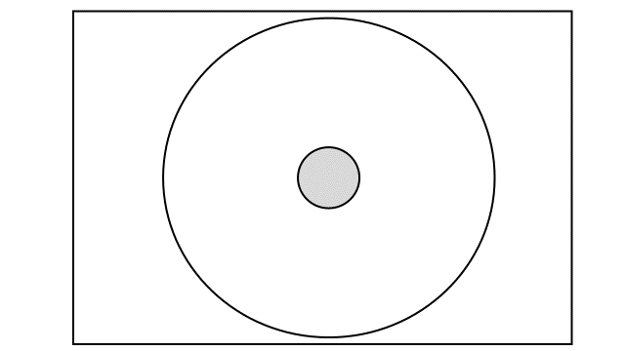

Describing – The Bubble Map
The Bubble Map is used to describe qualities associated with a specific object, person, idea or event. Bubble Maps develop pupils' abilities to identify qualities and use descriptive words. In the centre circle, write the word or thing being described. Write the adjectives or adjectival phrases in the outside circles.
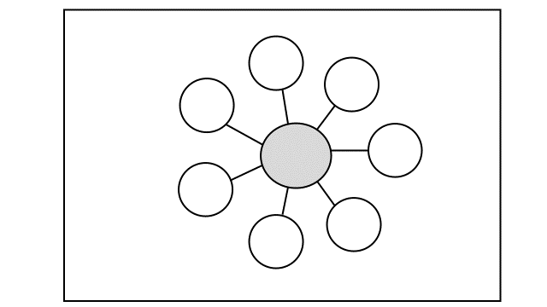

Comparing and Contrasting – The Double Bubble Map
The Double Bubble Map is used to identify points of similarity and difference, to compare and contrast. The two ideas, objects, events, people or characters being compared are written in the two larger centre circles. Outside bubbles contain things that are only possessed by, or are relevant to one of the two ideas, items or events. The central bubbles that are connected to both circles contain features common to both. Unlike the Bubble Map, the Double Bubble Map is not limited to the use of adjectives.

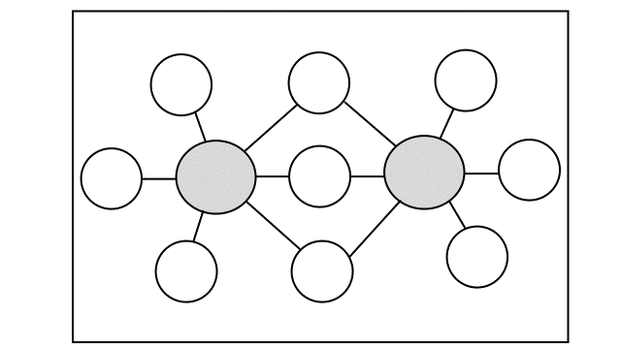

Sequencing – The Flow Map
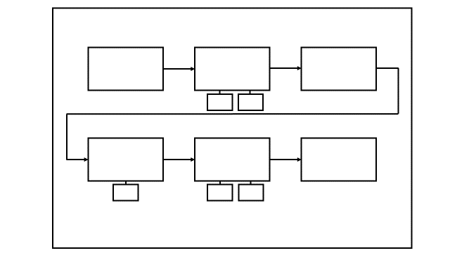
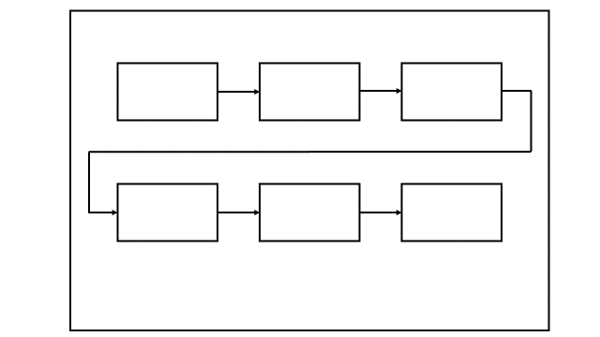
Flow Maps sequence a chain of events or processes, mapping the relationships between stages and sub-stages. The Each rectangle is linked by an arrow denoting the sequence or order. Sub stages may also be included in smaller rectangles adjoining the main rectangles. Note that when a second row is needed the sequence proceeds from left to right in the same way as reading text.
A Flow Map with sub-stages
A Simple Flow Map

Whole to part thinking (Deconstructing) – The Brace Map
Brace Maps allow pupils to understand the relationship between a physical object and its parts, and to analyse the structure of an item. On the line to the left, write the name of the whole object. On the lines within the first brace to the right, write the major parts of the object. More braces may be added for additional sub-parts.
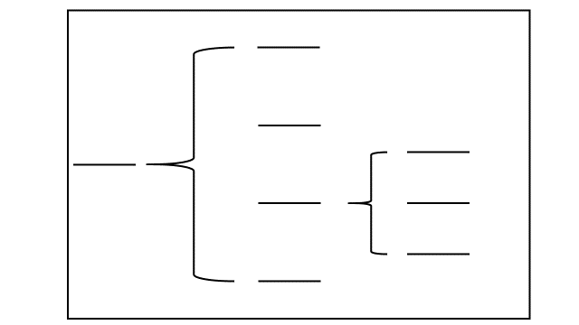

Categorising, Classifying, Sorting –The Tree Map
Tree Maps are used for classifying and grouping ideas, objects, people or events. On the top line, write the category or topic name. Below that begin writing sub-categories. Below each sub-category write specific items for that section.
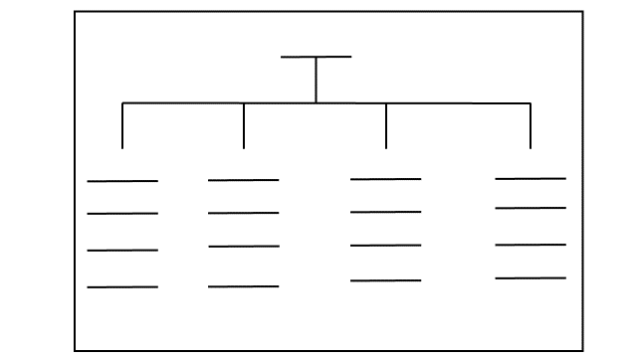
Identifying Cause and effect – The Multi-Flow Map
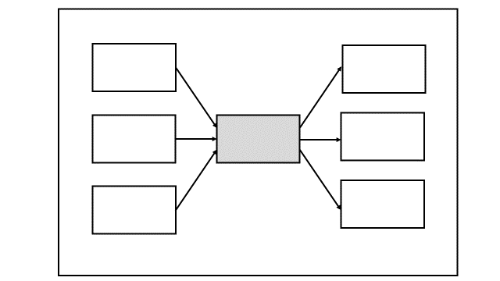
Multi-Flow Maps are used to explain causes and effects. They help pupils to analyse a situation by looking at what led to an event and what resulted from it. In the centre rectangle, write the event that occurred. In the rectangle(s) to the left, list the causes of the event. Write the consequences of the event in the rectangle(s) to the right of the centre rectangle. Note that arrows indicate the “flow” of causes and effects from left to right.
Establishing Relationships by Analogy – The Bridge Map
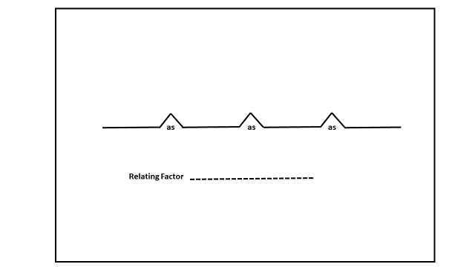
Bridge Maps allow students to identify relationships by way of analogies. In the space provided write in the relating factor. The relating factor is the connection that fits both sides of an analogy. On the top and bottom of the left side of the bridge, write in the first pair of things that have this relationship. On the right side of the bridge, write in the second pair of things that have the same relationship. Continue the Bridge Map by adding additional pairs of factors that bear this relationship.

The Frame of Reference
Note that all Thinking Maps may be drawn with a rectangle which surrounds the map, as shown in the example below. This is called the Frame of Reference. In this space pupils may record the sources of their evidence, or indicate how they “know what they know”. The Frame of Reference may also be used to indicate a particular perspective or point of view.

